Automated Condition Analysis of Roads

Joel Stansbury, Claire Chan, and Anna Shonia

CX 4240 - Spring 2019



Video showing interactive visualization created for this project. Markers are displayed at all of the areas where a surface imperfection was detected, and colored according to the type of imperfection. Google street view is used to confirm the accuracy of our algorithm.

1. **Introduction**

We are seeking to automate the collection of data regarding the condition of public roads as it pertains to surface cracking, potholes etc. The current system employed by the Georgia Department of Transportation (GDOT) consists of manual analysis of road surface condition being performed in accordance to a scheduled maintenance program which prioritizes high traffic areas, determined via [traffic monitors](http://geocounts.com/gdot/) (Wiegand 2019), wherein, an employee characterizes the state of the road based on a section used for observation (Tanner 2015). This type of analysis assumes that surface damage is distributed somewhat uniformly, and is severely limited in scope due to the large time investment necessary to collect the data. Additionally, historical data shows a large amount of variation in analyses, making them difficult to use in predictive algorithms (Tsai 2008). Some research has been done

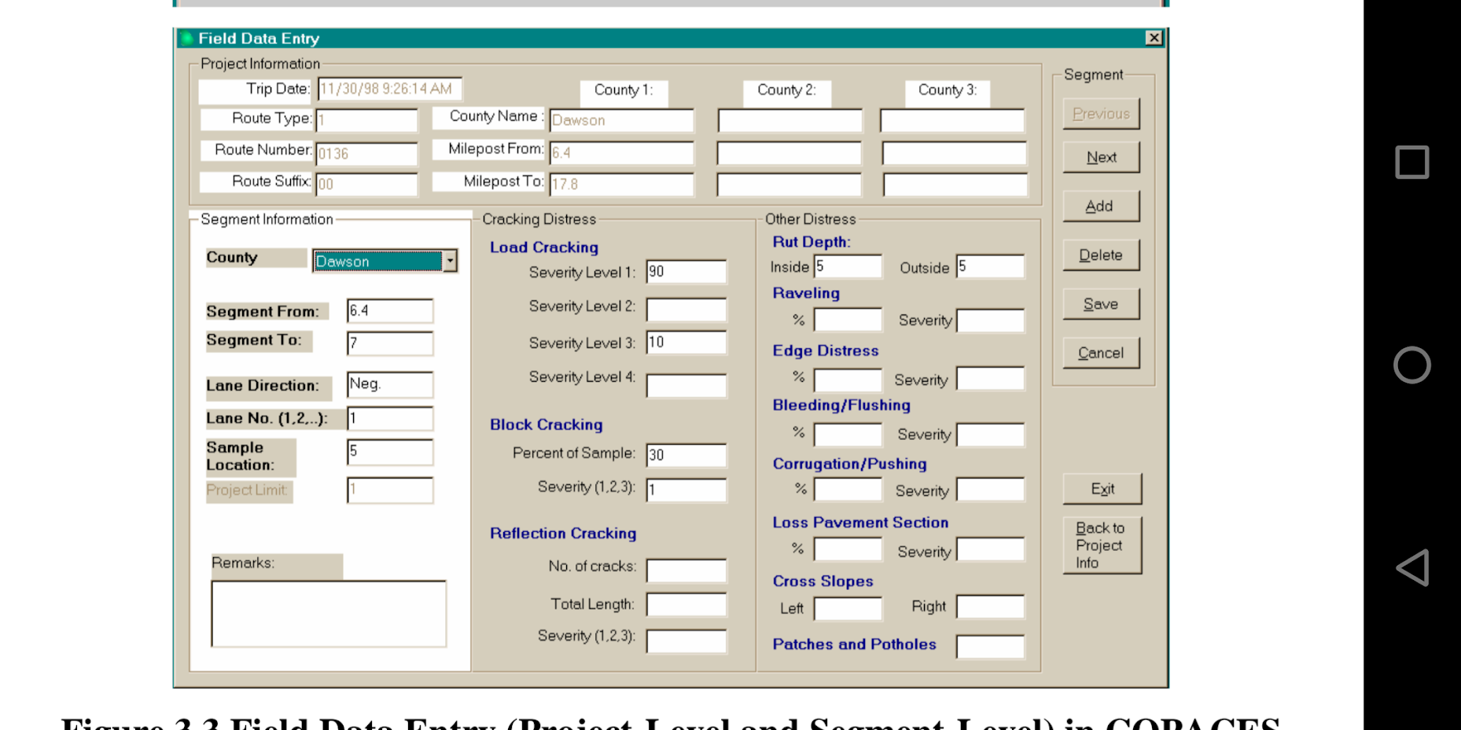

(Fig. 1) Condition analysis survey used by GDOT. Figure from (Tsai 2011), "Optimization of Safety on Pavement Preservation Projects"

1. **Methodology**

Our solution to the pitfalls of the current system is to utilize the accelerometer, microphone and gps module inside smartphones to detect anomalies in the road surface. The processing of the data obtained from our mobile app can be broken into two objectives, find imperfections and classify them. In order to detect imperfections we place a volume threshold on the audio. If the threshold is exceeded, then we assume the cause of that spike in audio is some type of imperfection in the surface of the road. In order to classify the data points into separate categories of imperfections, we find the frequency spectrum at all of the points where the volume threshold was exceeded. The hypothesis here is that every type of imperfection has a characteristic frequency spectrum. We also include the maximum and standard deviation of acceleration in the feature matrix, which correspond to the maximum force and intensity of vibration experienced by the car. This results in an N*256 dimensional feature matrix: N imperfections detected in total, 250 frequencies (0-250Hz) and 6 measurements corresponding to acceleration (max and std. deviation for each spatial dimension).

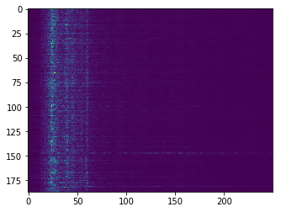

(Fig. 2) Visual representation of our feature matrix. This shows the frequency distributions of all of our data (datapoint index is numbered on the y axis, x axis denotes the frequency, brightness shows how dominant a given frequency is in the audio corresponding to that datapoint.)

Once we have populated the feature matrix, we perform dimensionality reduction (singular value decomposition) to obtain the first *m* principle axes to obtain an N*m dimensional feature matrix that is then passed into a Gaussian Mixture Model classification algorithm with *n* clusters. We tune *n* and *m* to maximize a custom precision metric, which we believe accurately represents the utility of our project.

1. **Results**

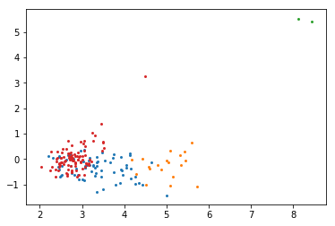

(Fig. 4) First 2 principal axes of our feature matrix (colored according the the cluster assignment GMM.)

To evaluate our algorithm and results, we used a few measurements. First, we found the Davies Bouldin score, which was 1.600. This index is the ratio between intra-cluster distance and inter-cluster distance. It represents the average similarity between each cluster. For this score, a low intra-cluster distance means high intra-cluster similarities, and high inter-cluster distance means low inter-cluster similarities. The lower this score is, the better. We also calculated the Silhouette score, which turned out to be 0.378. This is a measure of how similar the object is (average distance) to its own cluster compared to other clusters. The higher this score is, the better (on a scale of -1 to 1). A high score indicates well clustered results, while a low score indicates that there may be outliers.

We also tested the precision of our app’s anomaly detection using a second clustering method, Density-Based Spatial Clustering of Applications with Noise, or simply, DBSCAN. Because the app used audio to collect data on road conditions, it could have picked up other sounds from driving, such as a cough or a honking car.

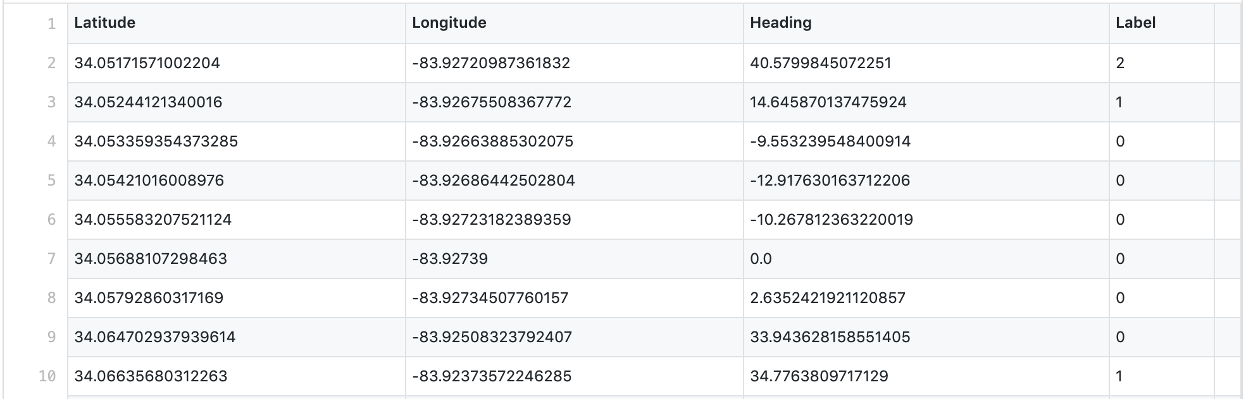

(Fig. 5) Raw data on 187 points in the road and the latitude, longitude, heading (in degrees) and label (anomaly type) for each. We converted this .csv file into a matrix to be fed into DBSCAN.

To verify that a data point was most likely due to an imperfection in the road surface we count the number of times something was detected at that location, this should have a maximum of 5 (the number of times we drove over the road). We used DBSCAN, with an *eps* parameter of 0.0002 (which corresponds to about 5 meters), to cluster the data according to their latitude and longitude coordinates. This process resulted in 45 clusters, or 45 potential anomalies detected along the route. We found the size of each cluster and calculated the average size to be 4.227. This average would appear to be quite good given that it is close to 5. However, we also had to account for the possibility that anomalies classified into the same cluster may actually be on opposite sides of the road. (DBSCAN would cluster them together due to their similar spatial positioning.)



(Fig. 6) DBSCAN would cluster the points in magenta together, but there may actually be two different anomalies on opposite sides of the road. This image is not based on actual data.

To tease out differing orientations, we looped through each of the 45 clusters, set the heading of the first data point as a control, then compared it to the heading of every other point in the cluster. If a heading fell within a 180° range of the control, the corresponding data point would be put into one cluster; otherwise, it would be put into a new cluster.

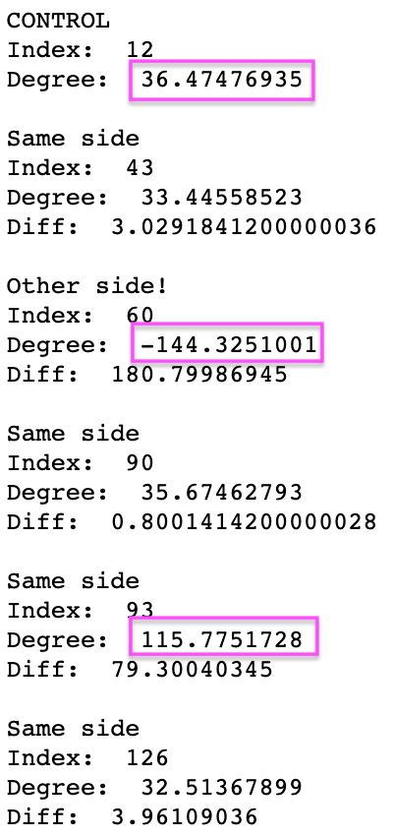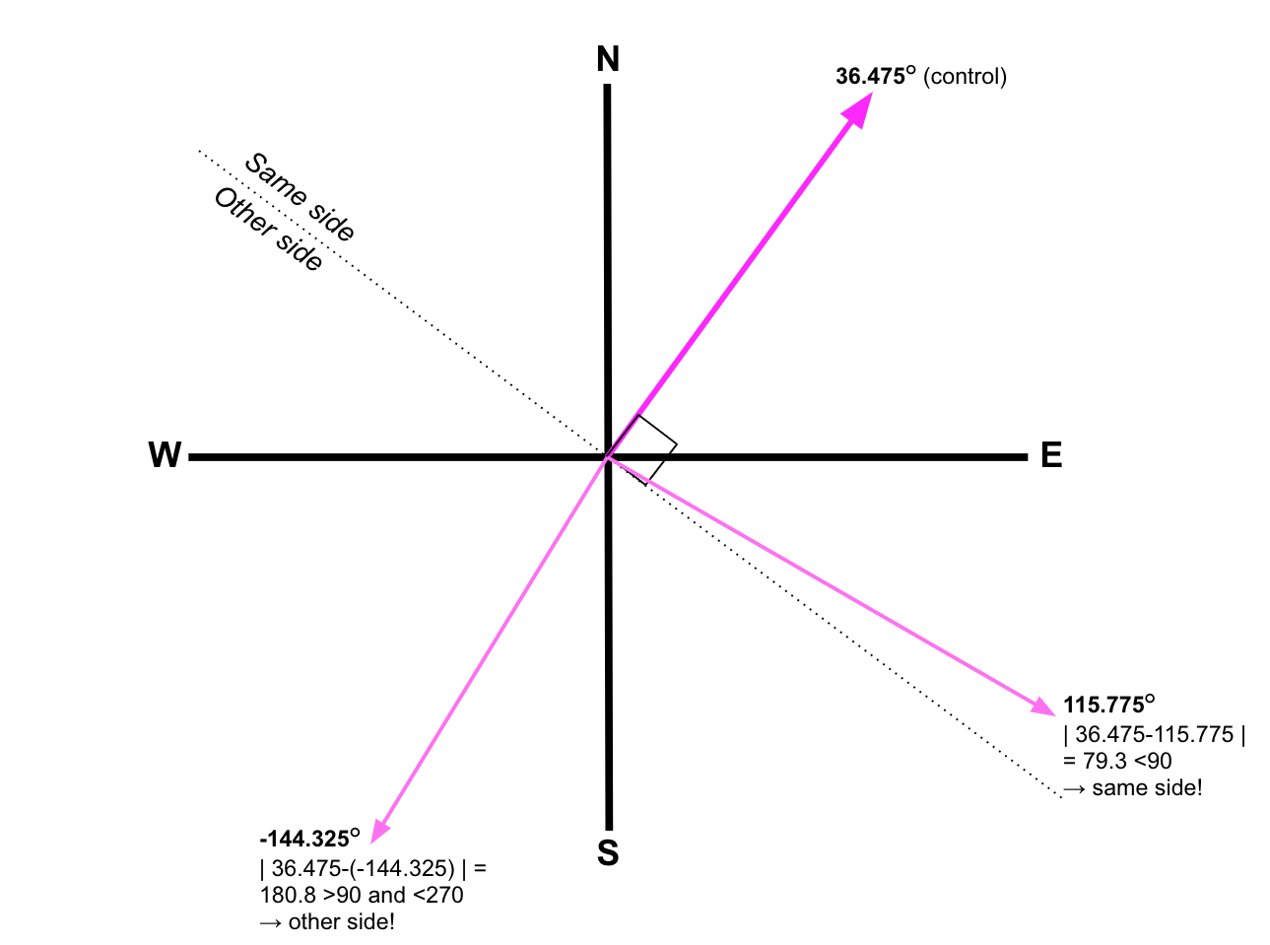

(Fig. 7) Comparing three points in cluster 12 based on their orientations (boxed in the left). On the compass rose, any points to the right of the dotted line fall on the same side of the road; to the left, other side of the road.

We then applied DBSCAN to both clusters and re-calculated the average cluster size to be 2.835. Although this is lower than our original average of 4.227, it still provides evidence that our results are replicable and that a volume threshold is a reliable method for anomaly detection.

Additionally, for every imperfection, we measured the precision of our classification. If a particular imperfection was classified in the same category every time it was detected, the classification precision would be 100% for that imperfection. The average clustering precision for our data set was 95%. This number is inflated by imperfections which were only detected once or twice. To address this, we provide a table showing the average cluster assignment precision, where min detections is the number of times an imperfection must have been detected (out of a maximum of 5 since we drove over everything 5 times) before considering it in the calculation.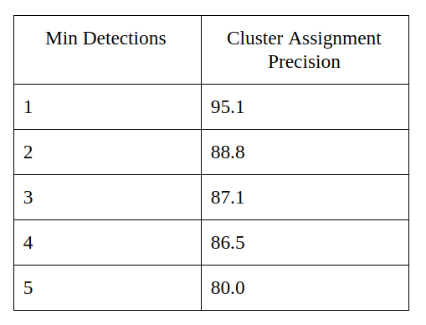

1. **Conclusion**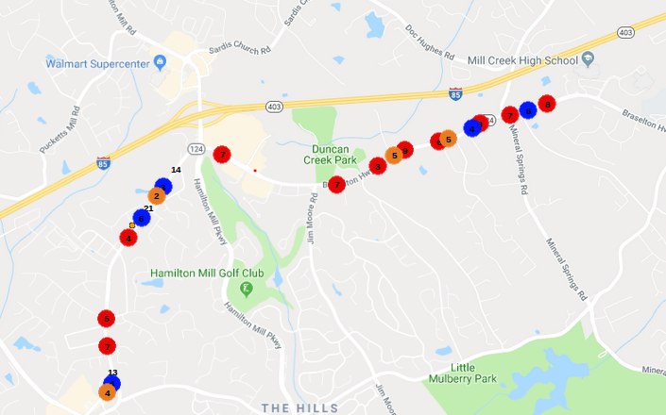

(Fig. 8) Results of clustering algorithm over the section of road we analysed.

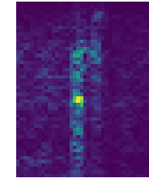

(Fig 9) Example of a spectrogram showing how the frequency spectrum of a crack in the road changes in time

The results of this project are very promising for the future of road maintenance automation. Figure 8 shows all of the imperfections our algorithm detected. What is obvious from this image is that there are sections of the road which have fewer imperfections on them and are therefore in better condition than others. The important thing to remember here is that we made 5 passes over the road, that is to say, if 5 detections occur in close proximity to each other, then you can be extremely confident there is an imperfection at that location. Over the 64,000 meters we drove there were 187 detections, so for every meter there is a 0.0029 chance of getting a detection, and a 2.13E-13 chance to get one in the same spot 5 times in a row if these points were distributed randomly. In other words, our detection method demonstrates extremely consistent behaviour.

From this perspective, our goal of providing a repeatable method of quantifying the condition of a road was achieved entirely through the use of a volume threshold, no machine learning. Our method of classifying these imperfections was not so successful. While we do see consistent and repeatable classifications, the boundaries between categories (Fig. 4) are not clear enough to consider this reliable, nor are the meanings of the clusters clear enough to be of much use to the DOT, i.e. we were unable to show that a particular cluster definitely represents cracking within the wheel path for example. In the future, more work must be done on the classification algorithm. We believe we can significantly improve our classification precision by using labeled data and taking the time evolution of the frequency distribution into account, e.g. using spectrograms (fig 9) as the input for a convolutional neural network.

**Related Works:**

Tanner, Paul. Office of Transportation Data  
(OTD). 2015. Available at: http://www.gampo.org/docs/20170925_gdot-pres_otd-overview.pdf. Accessed Feb 18, 2019.

Wiegand, Kiisa. "Georgia's Traffic Monitoring Guide". 2018. Available at: http://www.dot.ga.gov/DriveSmart/Data/Documents/Guides/2018_Georgia_Traffic_Monitoring_Program.pdf. Accessed Feb 20, 2019.

Tsai, J. Wang, Z. "Improving GDOT’s Highway Pavement Preservation". 2008. Available at: http://www.dot.ga.gov/BuildSmart/research/Documents/05-19b.pdf. Accessed Feb 21, 2019.

Tsai, J. Wang, Z. "Optimization of Safety on Pavement Preservation Projects". 2011. Available at: http://www.dot.ga.gov/BuildSmart/research/Documents/092011.pdf. Accessed April 15, 2019.